## horizontal line

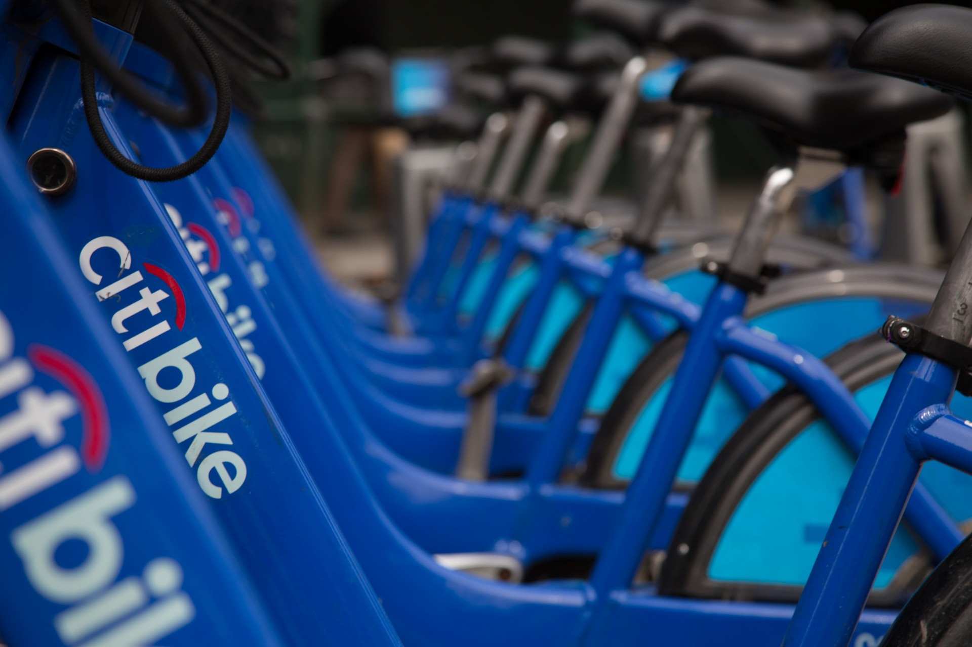

Jersey City CitiBike Data Analysis

20200612

**─**

Nickolas Black

# 

# Introduction

**Background:**

CitiBike is a public bike sharing system currently serving the New York City boroughs of Manhattan, the Bronx, Brooklyn, Queens, and parts of Jersey City, New Jersey. Cyclists have the option of registering for a yearly subscription at the cost of $95, a weekly subscription for $25, a 24-hour pass for $9.95, or they can choose to pay for a single ride at the cost of $3. With each rental, every cyclist is allowed 45 mins of bicycle use until additional charges are accrued. Typically, cyclists can rent a bike from one of the more than 600 CitiBike stations located around the NYC metropolitan area and return it to another bike station.

**Problem:**

This project analyzes the most recently published Jersey City Citi Bike data for the first quarter of 2020. The goal is to find the neighborhoods that Citi Bikes are most often used, the average age of current CitiBike users, the top 10 venues in the neighborhoods with the most citi bike traffic, and to cluster the neighborhoods using k-means clustering.

**Interests:**

This project is designed to target bicycle enthusiasts who are looking to relocate to Jersey City and bicycle businesses that are looking for venues to advertise their products and services. The descriptive characteristics of the individual user data will provide advertisers with an idea of a targeted demographic for advertisements. The location data will provide bike users with an idea of which neighborhoods bikes are more or less readily available and where they can connect and network with fellow biking enthusiasts.

We will focus on the neighborhoods with the highest number of bicycle traffic, a description of the people who use the bike sharing program, and the top 10 venues in the neighborhoods with the most traffic.

# Data

Based on our description of the problem, factors that will influence our decisions are:

* The most commonly used Citi Bike Terminals in Jersey City.
* The average age of Citi Bike users.
* The most common venues in the areas with the most Citi Bike traffic.

The following sources will be needed to generate a solution to the given business problem:

* [Part 1: Creating a Data Frame containing real world data of recent Citi Bike usage from NYC Open Data](https://www.citibikenyc.com/system-data): A dataset consisting of CitiBike meta data containing: Trip Duration (seconds), Start Time and Date, Stop Time and Date, Start Station Name, End Station Name, Station ID, Station Lat/Long, Bike ID, User Type (Customer = 24-hour pass or 3-day pass user; Subscriber = Annual Member), Gender (Zero=unknown; 1=male; 2=female), and Year of Birth.
* Part 2: Creating a new data frame of the neighborhoods with the most Citi bike usage, their coordinates, and the 10 ten venues using the foursquare API.

# Methodology

**Part 1: Examining CikiBike Demographics**

Once the data frame is loaded into the notebook, a quick examination of the data has led to a few quick immediate conclusions about CitiBike usage in Jersey City:

* The average CitiBike ride in Jersey City lasts for a total of 30 minutes.
* The shortest bike ride was roughly one min long, which suggests that there may be some noise in the data from registered bike usage that went actually genuine bike rides.
* The average Citibike user was born in 1979, or is approximately 41 years of age.

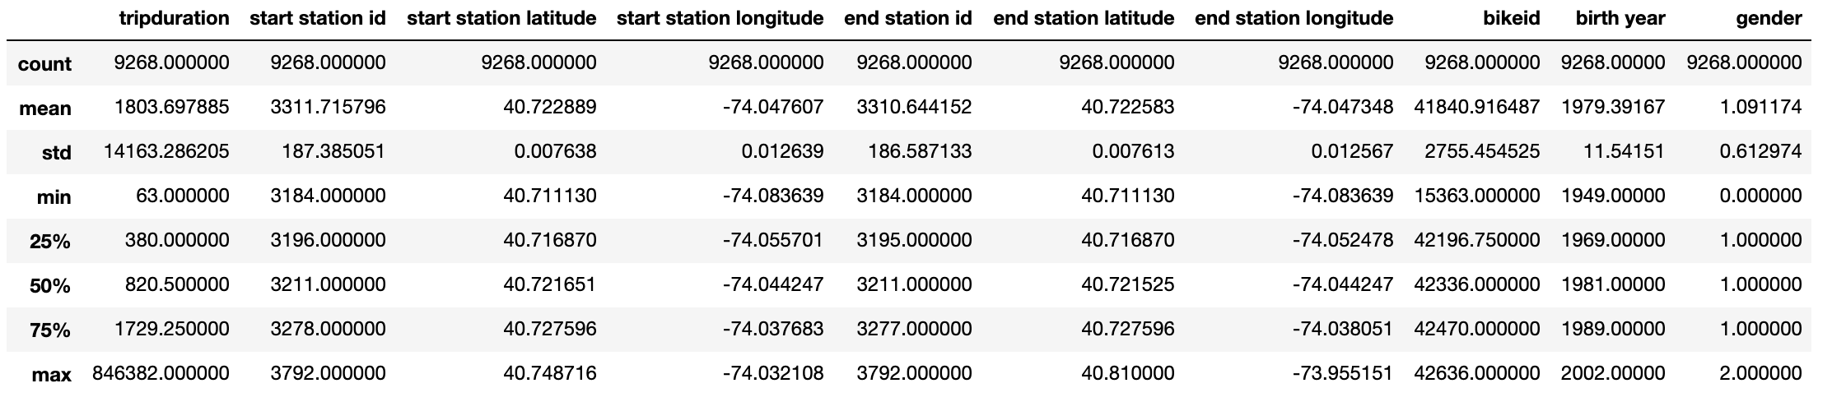

This visualization shows the distribution of the age of CitiBike users. Cyclists who are about 51 years old use CitiBike more than twice as much as any other age group. However, the data also suggests that Cikibike is very popular with millennials. In fact, the 8 out of the top 10 age groups are members of this generation, with the top 75 and 50 percentiles having been born in 1989 and 1981 respectively.

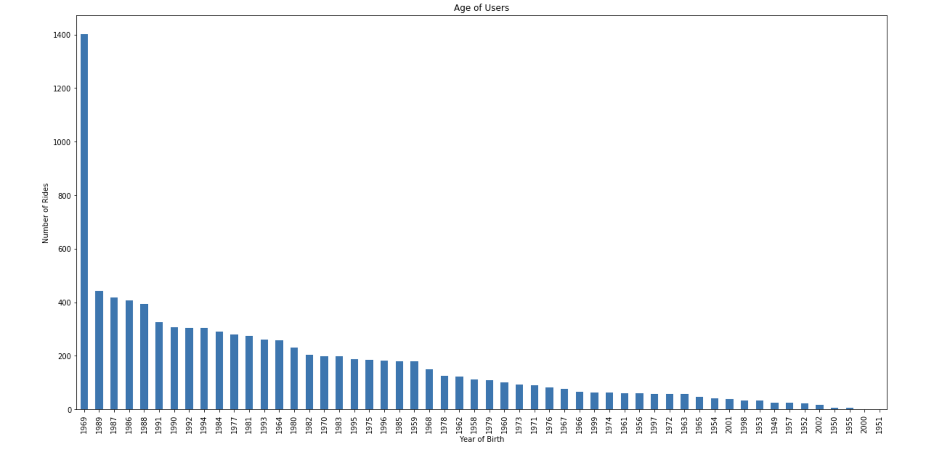

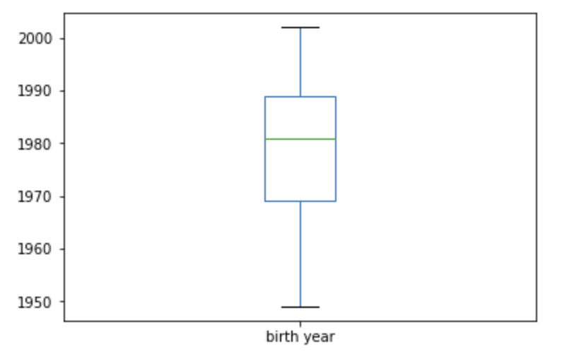

Upon examination of the gender statistics, I found that men used CitiBike during that time period more than twice as much as women have. While Newport Parkway is by far the most popular CitiBike station used in Jersey City, men prefer to rent bikes from the Sip Ave station. Sip Ave is also not very popular among women cyclists. Beneath the gender distributions are the top 10 venues to each station in the top 5 stations for men and women.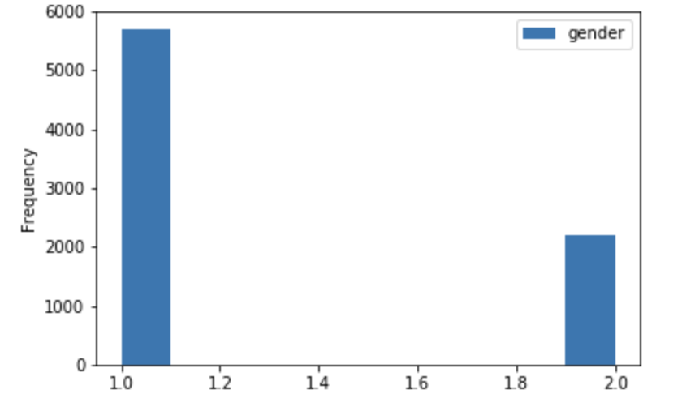

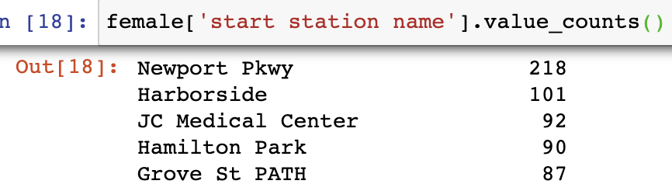

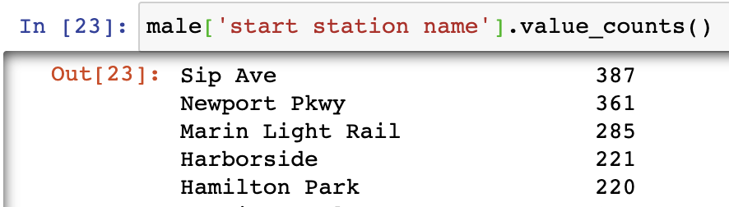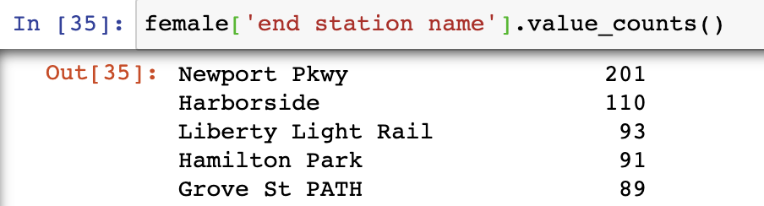

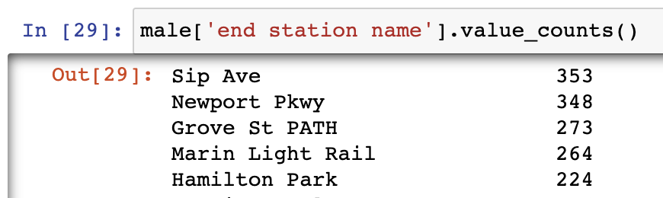

**Grove Street Path**

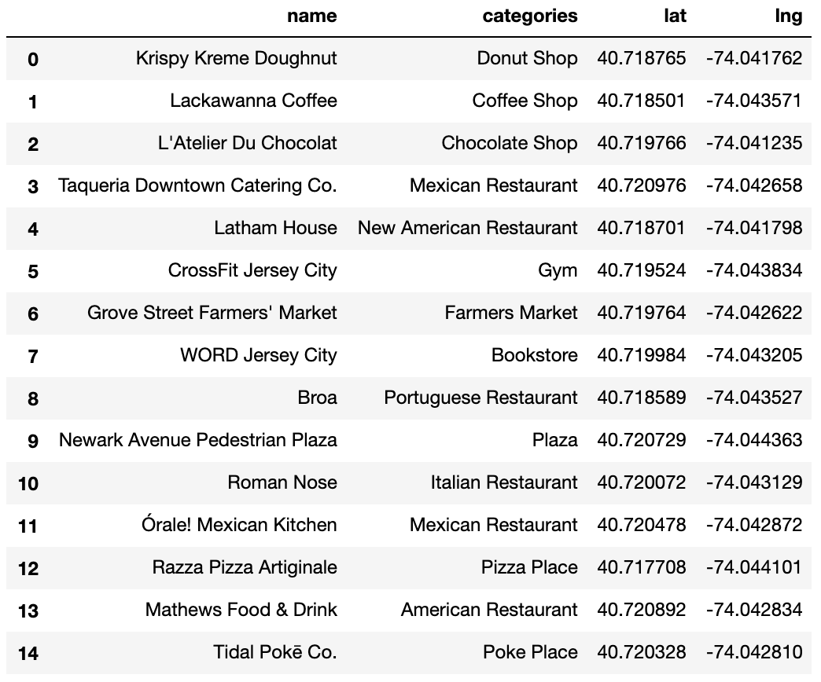

**Hamilton Park**

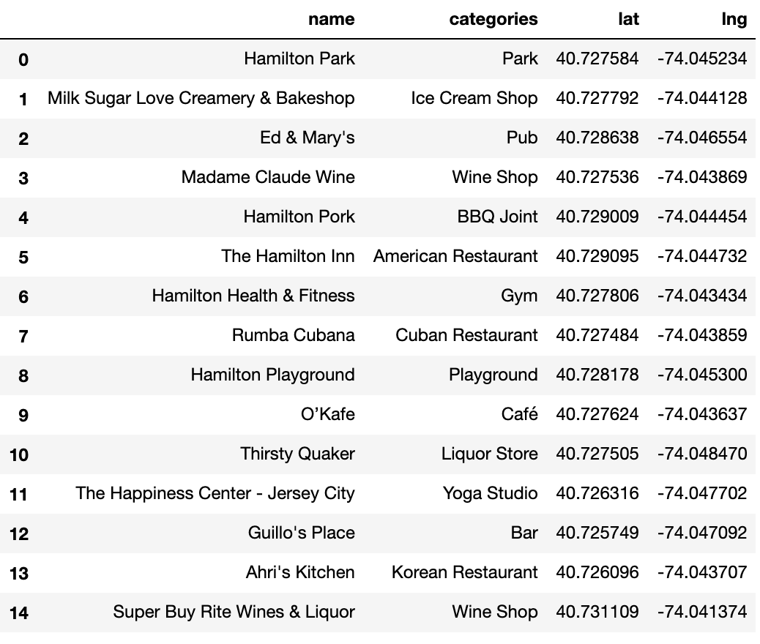

**Harborside**

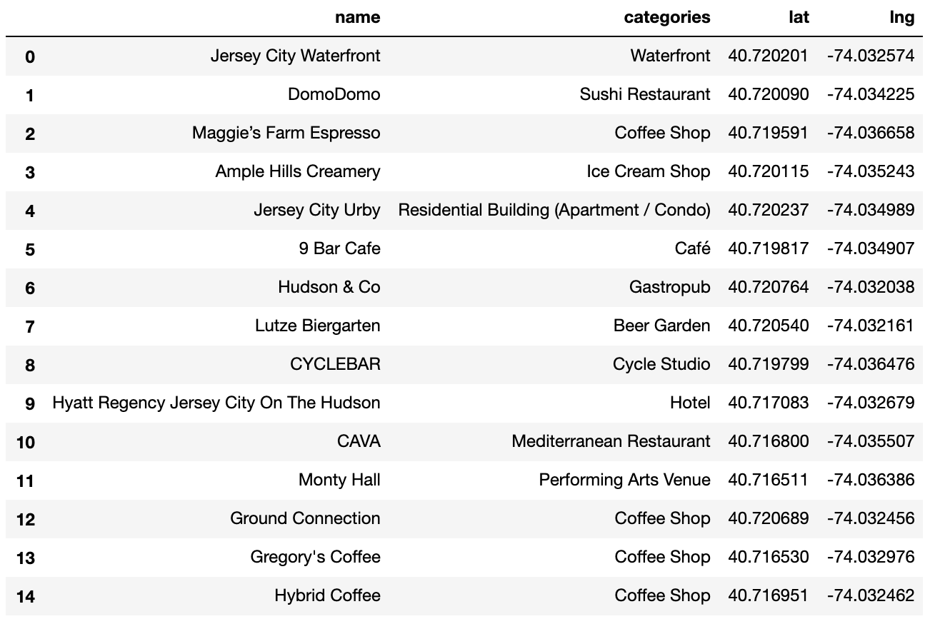

**Marin Light Rail**

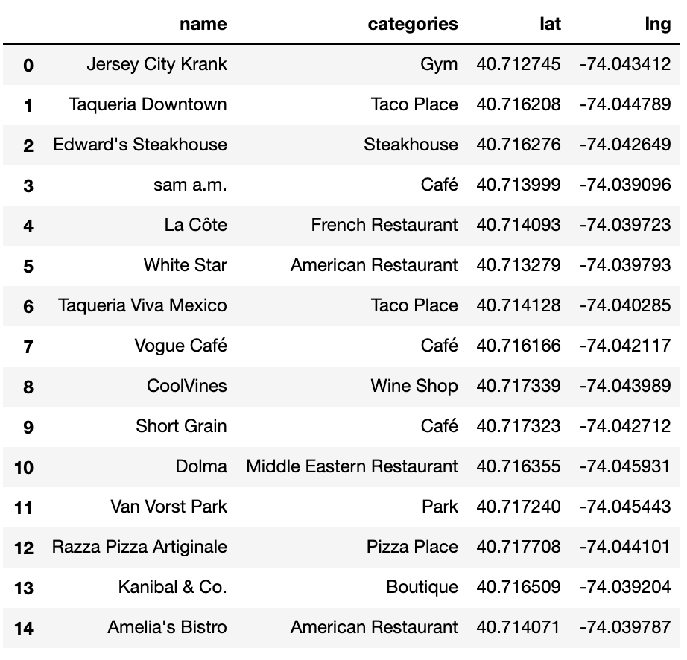

**Sip Ave**

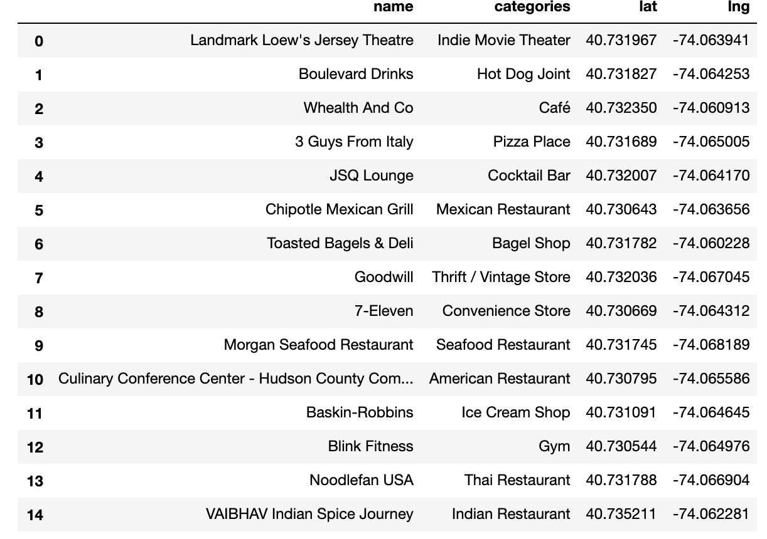

**Newport Parkway**

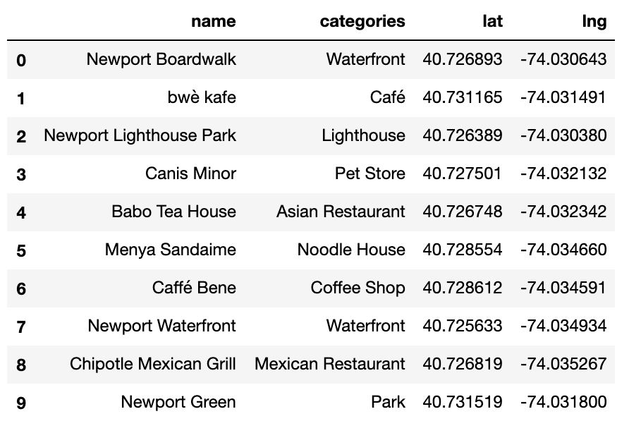

**Part 2: Clustering Stations**

Below we can see the clustering of the neighborhoods. One hot coding is done on the venues data. One hot coding is a process in which the data is converted into a form that could be provided to the machine learning algorithms. The venues data is then grouped by the station and the average is calculated, finally the top ten venues for each neighborhood is calculated.

To help people find similar stations, we will cluster the stations using K-means clustering, which is a form of unsupervised machine learning algorithm that clusters data based on a predetermined size of clusters. For this project we will use 5 clusters. The purpose of clustering is to target individuals that may use bike stations that are located in similar areas or are used by a similar demographic. 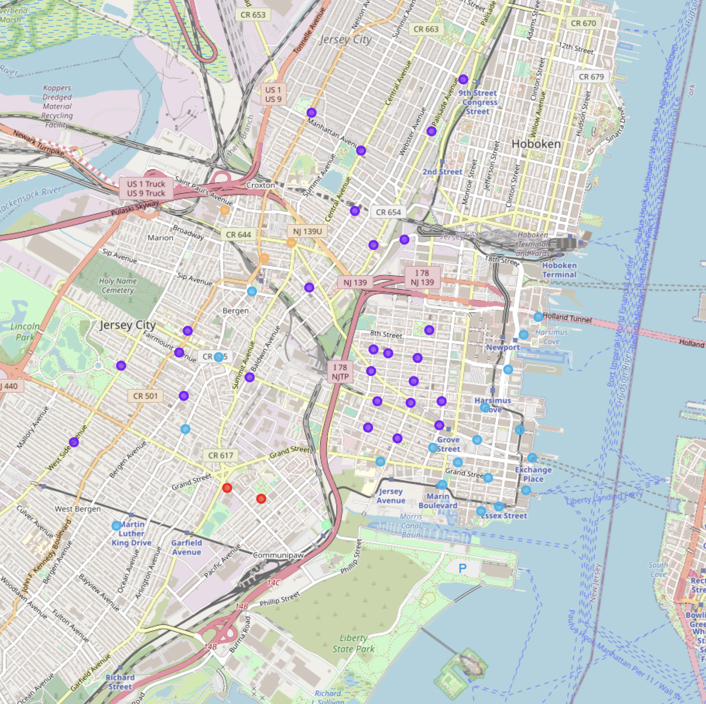

# Results:

After Clustering the stations we could examine each cluster. Unfortunately the stations are labeled by the station ID instead of the actual name of the station. However, we could use the station Id to find the station name or located what cluster the station is a part of on the map.

The first cluster consists of two stations. The first most common venue here is the pizza restaurant. It's likely that if ads were placed in that pizza restaurant, advertisers could target cyclists who use CitiBikes at those two stations.

**First Cluster**

The second cluster consists of stations that are similar to Oakland ave. The most common venue in this area are bars, therefore it is likely that this part of the city is residential and full of nightlife venues. Therefore those venues should be used to advertise to cyclists in this area.

**Second Cluster**

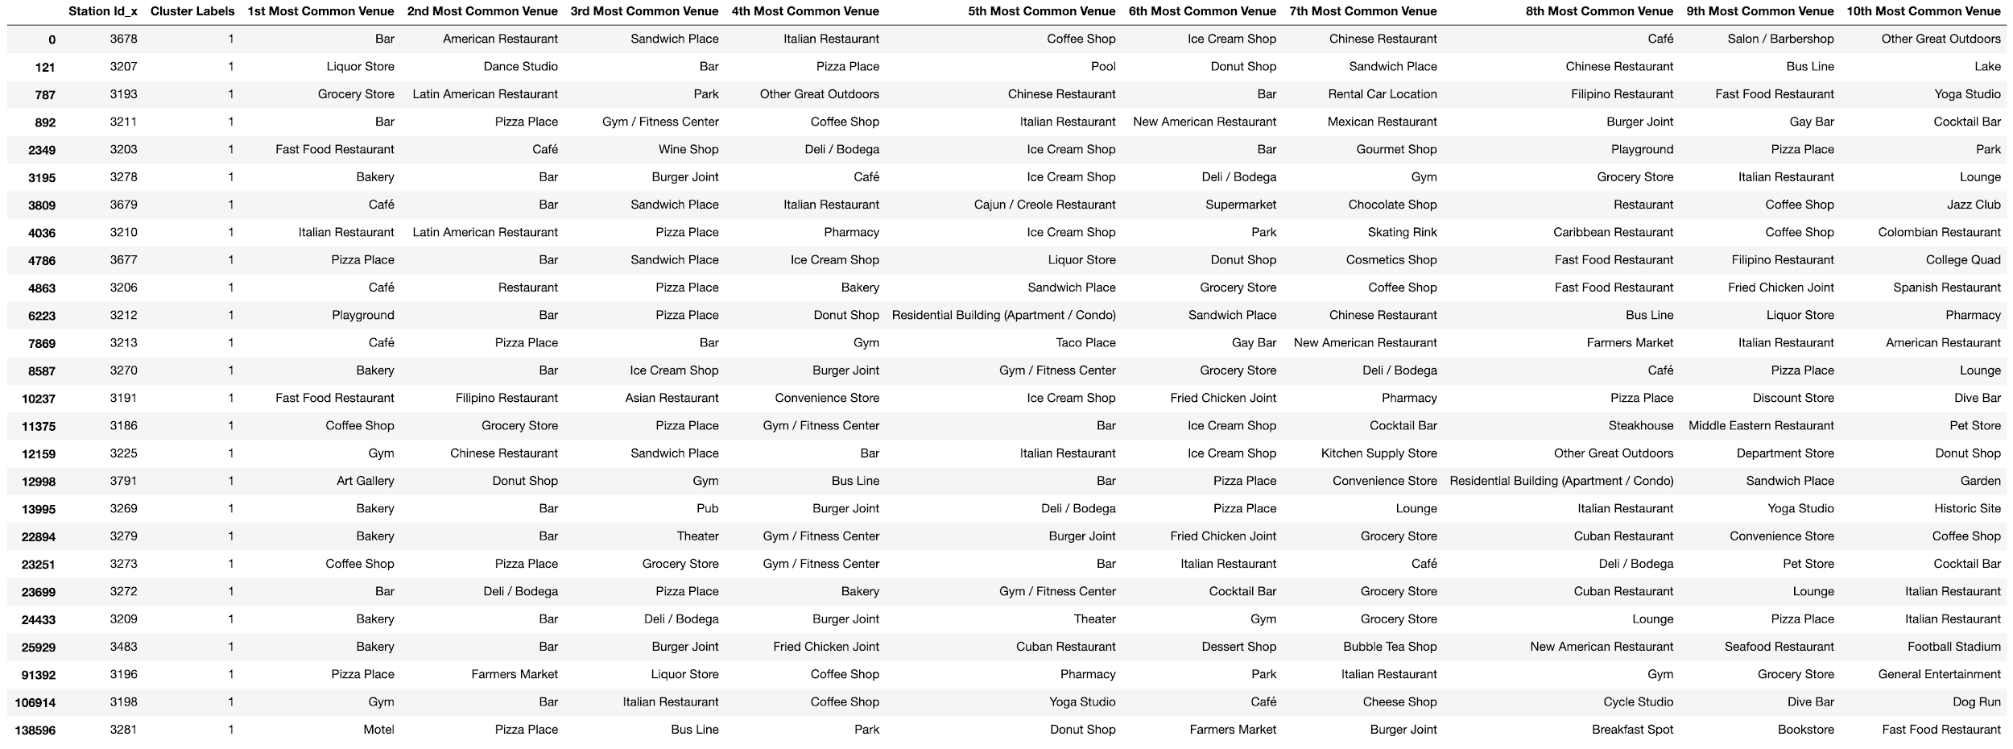

The third cluster includes Sip ave. which is a popular station used by women. This cluster is located by the waterfront, and is likely a tourist destination. From this area we would be able to see the beautiful skyline of the Financial District across the Hudson River. Advertisers may want to use these venues to target tourists.

**Third Cluster**

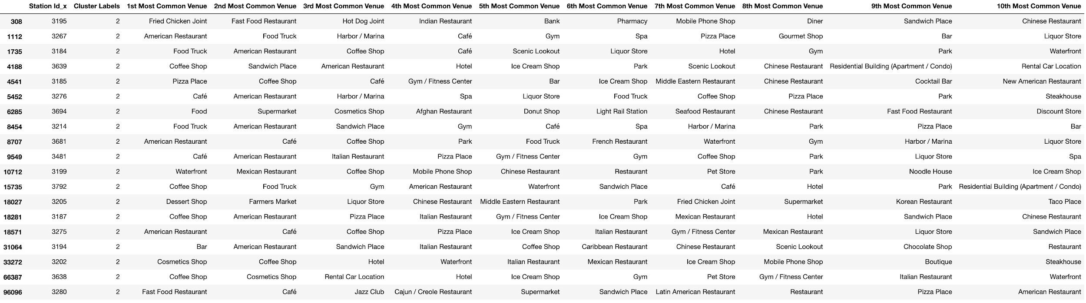

The fourth cluster only has one bike station and one major feature, which is a science museum. This location is likely The Liberty Science Center. I would concentrate on placing target ads there.

**Fourth Cluster**



The fifth cluster contains a series of Indian Restaurants. This area is likely a community of South Asian residents that immigrated to the United States from India. The ads that should be placed here should put that into consideration.

**Fifth Cluster**



# Discussion:

The aim of this project was to identify the type of people who are using Citibike in the Jersey City area and provide feedback to interested parties that may be looking to advertise bicycle related products to Citibike users. The typical Citibike user is a male born sometime in the 1980’s. He likely uses the Sip Avenue Station and stations in the surrounding areas. Women are less likely to use Citibike, however when they do, they use stations near Newport Parkway and along the Waterfront. For interested parties that are looking to move to Jersey City, they should consider moving to the Oakland Avenue area where there are numerous bars, restaurants, and likely other CitiBike enthusiasts.

# Conclusion:

This project helps a person get a better understanding of CitiBike Stations in Jersey City, New Jersey with respect to the demographics of the people who are using the CitiBike program and the common venues that are located around each CitiBike station. It’s always best to use technology to understand the institutions and systems that are a part of our everyday life. We could use this information to help people plan for the future and in extension live better lives. The future of this project should examine CitiBike Stations citywide and examine the economic considerations of each neighborhood.